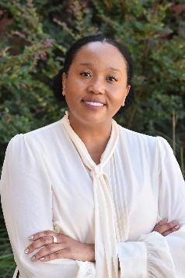

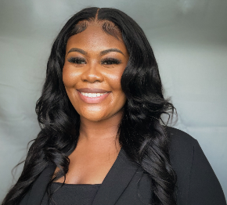

Passionate advocate for experiential learning, and creating transformational student experiences that foster personal and academic growth. My goal is to introduce internationalization into the curriculum for first-year students, bringing a global perspective to their education. By incorporating diverse cultural awareness and hands-on learning opportunities, I aim to prepare students for success in an interconnected world, empowering them to become culturally competent and socially responsible leaders.

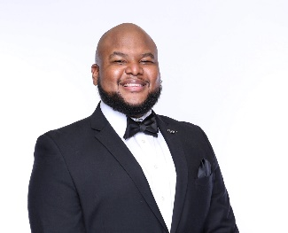



Dr. Lashonda Slaughter-Wilson is an Assistant Professor of History at Albany State University specializing in Early Modern European history.  Dr. Slaughter-Wilson is passionate about cultivating a love of history in her students and providing a global perspective on national and international events.