## GENOGRAM

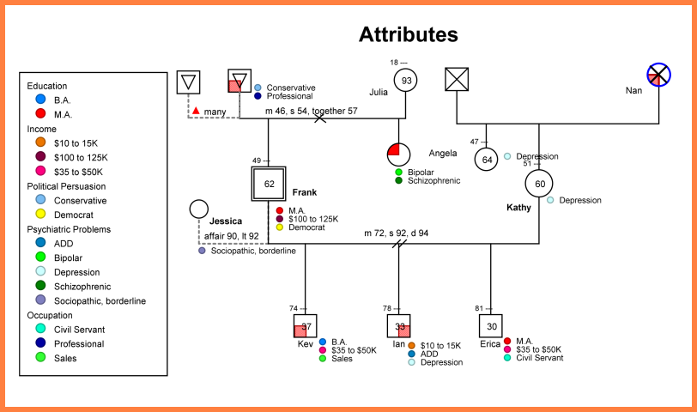

***Make sure you include a legend.***