The Purpose of Lean Six Sigma

Maquetta Hagan

Albany State University

Organization and Supervision in HIM: HITE 2110

Misty Neal

April 04, 2018

**Introduction**

The Lean Six Sigma has two powerful methods that can help improve any organization. This method provides organizations specific tools to enhance the capability of many business processes. “Research work on Lean, Six Sigma, and Lean Six Sigma has become increasingly present in the literature in the field of operations management and business excellence and has extended to other areas as the need for process improvement is more prominent” (Davidescu & Ghinararu, 2015, pg. 163). This method’s quality is a technique used to indicate a process that is well controlled. Lean Six Sigma decreases the organization's costs, increase profits, improves efficiency and customer satisfaction, and increases employee’s motivation.

**Decreases in Organization Costs**

Many organizations are challenged with rising costs and increasing competition on a daily basis. The Lean Six Sigma allows businesses to encounter these problems and grow rapidly in different areas. This method works in very small organizations with very large organizations. The Lean Six Sigma increases the revenue and reduces the cost. “The quality is contagious in every industry, if quality increases, the cost automatically goes down to withstand in the competition. Lean tries to decrease the wastage processes and reduce wastage, which helps to cut cost. Rectify the backdrops, the medical defectives, the cost can be controlled effectively which make a drastic difference and improves the patient satisfaction at lower prices” (Sai ram, 2016). Production costs are proven to drop when Lean Six Sigma is applied to inefficient processes. This method takes away all unnecessary steps in the production process. The Lean Six Sigma has been proven by research that it has helped so many organizations radically cut costs.

**Increase Profits**

The Lean Six Sigma has affected patient satisfaction and scheduling in many healthcare organizations successfully. Financial gains can improve the patient volumes for that healthcare organization and can improve the patient and provider stratification. To minimize the wait times for patients and to meet their appropriate needs the Lean Six Sigma has to be implemented. “The concept of Lean is to eliminate wasteful steps and create continuous improvement and flow through teamwork. Six Sigma focuses on the methodology to problem-solving, streamlining, and improving efficiencies” (Gavriloff, 2017). Some organizations have proven that the gross revue increased by going through the Lean Six Sigma. It takes the right strategy and determination to ensure that this method is inquired thoroughly. “Utilizing Lean Six Sigma methodologies allowed for the identification of the root cause of the scheduling problems and allowed for a more controlled patient flow, improved the number of patients seen each day, and increased efficiency of patient throughput. These factors allowed for an increase in gross revenue while not negatively impacting overall expenses” (Gavriloff, 2017).

**Improves efficiency and customer satisfaction**

Customer satisfaction is the key to Lean Six Sigma. Determining how quality issues impact customers is the first step that the team takes. The team will identify elements that may be required to help increase customer satisfaction. “A Six Sigma business strategy relies on statistical tools and specifically designed processes and methods in order to achieve measurable goals to pursue increasing efficiency and productivity, reducing waste and enhancing products and processes” (Jung-Lang, 2017). The Lean Six Sigma helps the top management to grasp the strategies by choosing strategically related projects. This method can prevent raising death rates, medical errors and many more. It also consents hospitals to providing lower costs and outstanding care to its patients and customers.

**Increases in Employee’s motivation**

When employees understand the Lean Six Sigma concepts and principles and being knowledgeable of how to use them, they will gain a boost of confidence. This method really allows employees to see themselves as problem solvers and recognize the defects as a chance to improve the organization. Proper training on implementing this method and recruiting more medical professionals or any other professional in that particular organization that are familiar with the Lean Six Sigma will help decrease the wastage and cut major costs. The Lean Six Sigma will allow employees have a new set of skills to apply in all aspects of their jobs. They may become more focused, data-driven and have more enthusiasm. Some organizations employees are not happy with Lean Six Sigma because it may cause major changes in that particular business which can lead to disagreements. This method takes collaborated teamwork and effort to make it a great success.

**Conclusion**

Many successful users engaging in this method have made workplaces more efficient and effective as possible, reducing waste and many more perspective changes. The bigger the problems the more effective the Lean Six Sigma is effective to that tactic. This method has proven to reshape many organizations. The DMAIC framework is used doing problem-solving. The five stages of DMAIC are defined, measure, analyze, improve and control. Knowing the background of the Lean Six Sigma and the main important facts will allow much more growth in many organizations. The Lean Six Sigma promotes better managers, employees and a better environment. This strategy may be the answer to many organizations downfalls.

**The Five Principles of Lean**

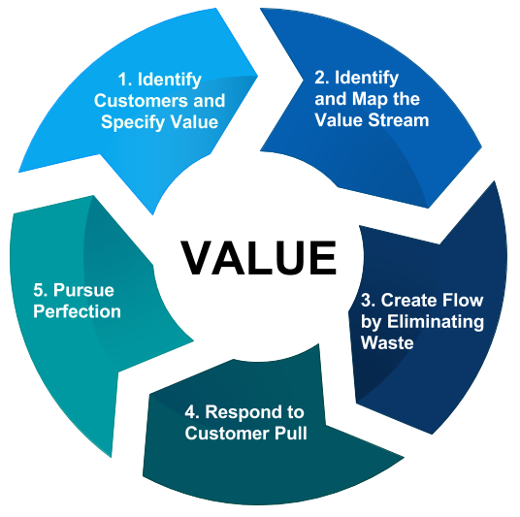

These Lean principles can be devoted to any process to reduce waste.

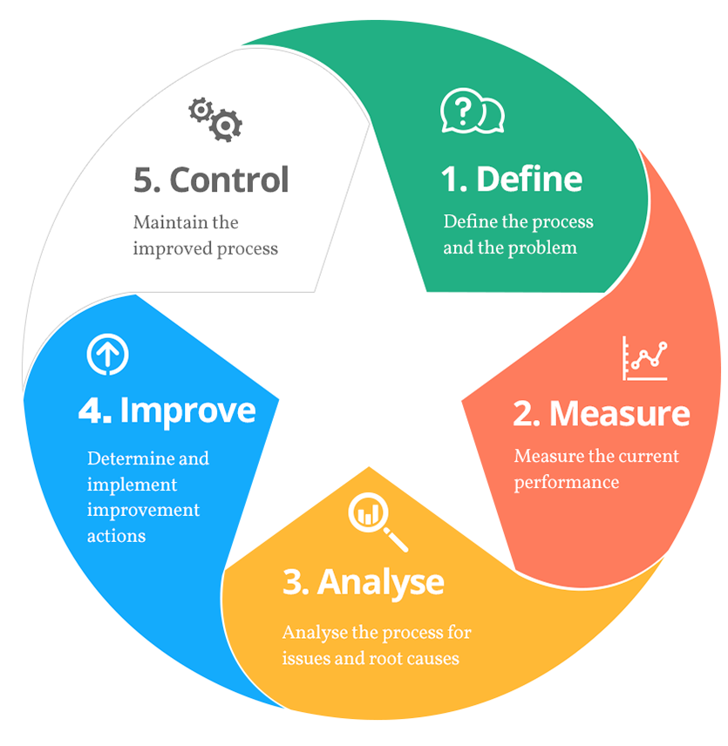

This is the Lean Six Sigma structured problem-solving methodology.

References

Bisk. (2018). Ways to save your money company money with Lean Six Sigma. Retrieved March 30, 2018, from https://www.villanovau.com/resource/six-sigma

Bisk Education

Gavriloff, C. (2017). The Impact of Lean Six Sigma Methodology on Patient Scheduling. *Nursing Economics*, 35(4), 189-193.

Jung-Lang, Cheng. “Improving Inventory Performance through Lean Six Sigma Approaches. *IUP Journal of Operations Management*, 16(3), 23-38.

Rastogi, A. (2018, March 12). A brief introduction to Lean, Six Sigma and Lean Six Sigma. Retrieved March 19, 2018, from https://www.greycampus.com/blog/quality-management

GreyCampus

Sai ram V1, 2. (2016). Implement Lean Six Sigma in Hospitals to reduce the Medical Costs and Improve the Patient Satisfaction. *Global Education Journal*, 2016(3), 56-71.

Wellwood, J. (2011, January 1). What are the benefits of Lean Six Sigma for your company? Retrieved March 30, 2018, from https://www.100pceffective.com/blog/benefits-lean-six-sigma-company

Business Improvement, Lean Six Sigma, Training

What is Lean Six Sigma? (2011, November 27). Retrieved March 19, 2018, from https://goleansixsigma.com/what-is-lean-six-sigma

Goleansixsigma.com

What is Six Sigma? (2009). Retrieved March 19, 2018, from http://asq.org/learn-about-quality/six-sigma/overview/overview.html

American Society for Quality