Fatou Kine Pene

MATH 2411

04/04/2018

Course writing component

Currently in this world, the advancement of technology has allowed many people to practice their profession quickly but also to predict future events and alarm people when a ruthless event will come. The meteorological forecast is the most remarkable. We can predict how the weather would be for the next month or the months to come using probabilities. Similarly, chemists reveal their results of chemical experiments in the form of probabilities. There are three tree mains ideas that will be discussed: probability and weather, the hazard games and chemistry experiments.

Last year, America had faced to 4 hurricanes. Some were manageable but some were really extreme and cause many damages. Before the hurricanes come, everybody was informed by the television, the radios or the newspapers. The meteorologist use probability to determine the degree of the intensity of the weather whether it is the wind, the rain or the snow. Without probability, the weather broadcast, certainly would not exist. Last year in United States of America, there were a hurricane named Maria. It mostly hit Porto Rico, Virgin Islands and Dominica. Fortunately, at least everybody knew about the danger of event and was prepared for all type of situation. It had been a month or at least two weeks that the new of the famous hurricane was broadcast all over the country. But for some, it was the total disaster. Some people has lost their property and according to Buzzfeed “Some 80 percent of the USVI remained without power more than a month after Maria [battered the U.S. territory](https://www.buzzfeed.com/briannasacks/six-weeks-after-hurricanes-hit-power-and-fresh-food-still?utm_term=.atNRqNrXw#.beq5Gmw0N)” it was a nightmare for those who stayed at the city and didn’t know where to go for shelter before the hurricane come.

Another aspect that makes use of probability is hazard games. They exist almost everywhere in the world and are only allowed to adults over the age of eighteen because they know well what they are doing. Recently in France, a young woman who just turned eighteen had played lottery and won a prize of $1000 every week for the rest of her life. It is sometimes a lucky game because some people had played several times and had just won small prizes. Most of the time, when people play, they know that the probability to win is very low but the game is very exciting and push you to play again and again. As an illustration, the table below from Business Insider will shows Powerball’s winning prize:

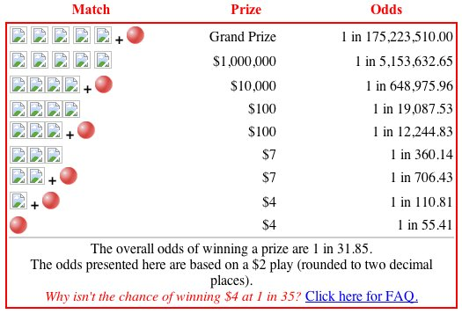

This table shows that we have 1 chance in 175,223,510.00 to win the grand prize and one chance in 55.41 to win only $4. The probability to win a big prize is extremely low. Likewise, the card game players like poker, patience, one-card, Texas Hold’Em, one card or blackjack are also very risky to play.

Beside the meteorologists and the card players, scientist also more particularly who’s who do chemistry, use a lot probability. The results of chemical experiments are sometimes unlikely. In laboratories, chemists tend to experiment to make sure that the product is in the norm. To do this, several experiments must be done and the probability that the test is ideal must be high after several experiment. If we take an example of mice in laboratories, we find that the animal undergoes several tests, whether physical or chemical. As an illustration, if the chemist gives a small dose of caffeine to a mouse, this one becomes very agitated. When the doses are increased, the mouse becomes more agitated and dies if a lethal dose has been given.

As shown above, we can say that probability is very useful when it comes to doing experiments, to predict what will happen. It is also very useful for casino and lottery players because, the more they know how to calculate how to have a probability of winning, the more they will have more chance to make money.