Darryan Martin

Math 1111

Champagne

13 November 2017

Polynomial functions are functions such as a quadratic, a cubic, and quartic, and so on, involving only nonnegative integer powers of x. Now, polynomial functions may sound complicated. It may also seem that the only time we would use a polynomial function is in a math class. In reality, we use polynomial functions outside of a math classroom and maybe on a daily basis. If you do not use polynomial functions on a daily basis then you might have witnessed it or looked at an object or a piece of construction that required the use of polynomial functions. I have witnessed how polynomial functions are used to make roller coasters, to make charts and their use in subjects other than math.

I have witnessed the use of polynomial functions to make all of those fun rides at amusement parks called roller coasters. If you were to put an equation of a polynomial function into a graphing calculator and graph it, you might get a graph that looks similar to a rollercoaster. The graph would build up and them dropped down. When using polynomial functions to make a design for roller-coaster engineers have to keep in mind that the shape of the graph cannot be graphed. The functions for roller coasters it must equal smooth curves, unlike the graph that represents the stock market. An example of a polynomial function that represents a basic rollercoaster would be f(x)= -0.000833(x3 + 12x2 -580x -1200). The graphs shows two basic loops that are formed from the function and how it would mirror a ride.

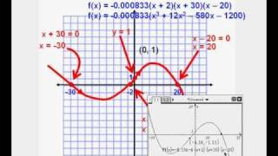

Another way I have witnessed polynomial functions in the real world is when it comes to representing information on graphs. These graphs can be seen on news channels or newspapers when the stock market is shown. Ever notice how the graphs are always rising and falling? People use polynomial functions to show how the prices continue to rise and fall in the economy. Stock market graphs do not exactly look similar to the graphs or rollercoasters. Unlike the polynomial functions for rollercoasters, the polynomial functions for stock market graphs are supposed to make the graph or picture more jagged and pointy.

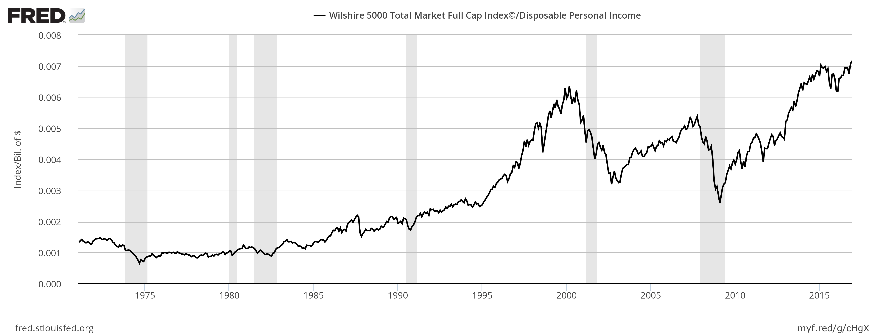

A final way I have witnessed polynomial functions is during my physics class as a junior in high school. Polynomial functions come into play when dealing with motion. Polynomial functions can be used to predict the motion of objects. The equation to calculate motion can be an example of a polynomial function and it: V2=U2 + 2as. By plugging in variables in the equation, one can calculate the distance of the object and plot it on a graph. One can also determine the height, distance and speed this way. In a way, this could be similar to the rollercoaster case of showing how polynomial functions can work in real life. Some differences would be that motion graphs would just rise and then fall, or they would stay in constant motion and then fall. The graph would also be pointy instead of having curves and the points would not rise once they reach 0 like the points on a graph from a roller coaster, unless the object bounces then the points would rise once more.

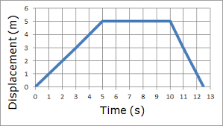

To conclude, polynomial functions can be seen in used in real life situations. Polynomial functions can be used to calculate the design of rollercoasters. Polynomial functions can also be used to predict the motion and position of objects in physics. Polynomial functions can also be used to represent graphs such as the stock market when showing the increase and decrease of sales in the economy.