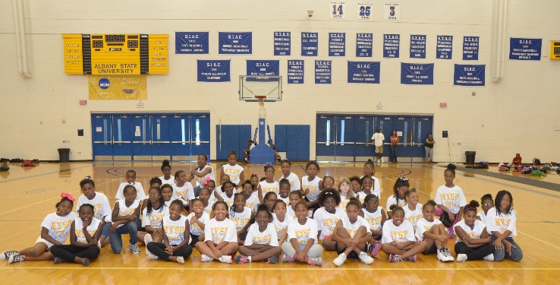

**Albany State University and the City of Albany, Georgia**

**Since 1968, the National Youth Sports Program (NYSP) has combined sports instruction with exciting educational programs for youths ages 9-15. Enrollment is open to all children in Dougherty County and surrounding communities.**

**The goal of the program is to engage students in activities that promote physical fitness, character development, civic responsibility and college readiness. Professionals will lead sessions on such topics as prevention of alcohol and drug abuse, nutrition and health, academic excellence, college and career visioning, and reading/writing instruction.**

**NYSP participants also receive a NYSP T-shirt, a daily USDA-approved meal, a free medical exam, and interaction with college students and professional staff. Youth will practice standard sports and learn new ones! Activities may include swimming, basketball, softball, tennis, volleyball, and dance/aerobics. Top quality sports equipment is provided by the program.**

Name: ____________________________________________________________Telephone:________________________________

Last First MI

Address: ___________________________________________________________M____F_____ Age: __________

___________________________________________________________ Birthdate: ______/______/__________

City State Zip Code

Returnee: Yes____No____ Number of Years: _______

Ethnicity: (check all that apply) ______American Indian/Alaska Native ______Asian ______Black or African American _______Hispanic ______Native Hawaiian/Pacific Islander _______White, Non-Hispanic ______Two or More Races ________Other

I, the student, volunteer and agree to take all training assessments and surveys offered in the program to track my progress in gaining knowledge and understanding of key concepts. I understand that my response on this item will not impact my eligibility to participate in the program.

Student Volunteers to take Program Assessments and Surveys? Yes____ No____

Student Signature _________________________________

Parent or Legal Guardian: __________________________________________________

Telephone: _____________________________ (home) ____________________________________ (work)

Emergency Contact: _____________________________________________Relationship:______________________________

Address: _____________________________________________________________________________________________________

|  |
| --- |
| I understand and consent that a medical examination will be required before enrollment in Program and that the host institution is authorized to obtain medical care or treatment deemed necessary.  Parent/Guardian Signature:________________________________________  Date: _________________________________ |

**Office Use Only**

Residing within target area: Yes___No____

Eligible________Non-Eligible_________

Medical examination record: