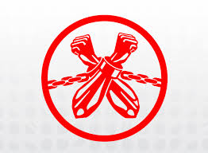

Students Working to End Modern Slavery

The Free Project

Wednesday, February 22nd   
at 12:30 pm

Simmons Hall

Conference Room 344

An interesting meeting for students wanting to join an organization dedicated to ending slavery locally and globally.

For More Info cal 430.1357

