Department of Fine Arts/ Division of Theatre

Celebrating Legendary “Triple Crown” Actress VIOLA DAVIS

Winner of an Oscar, an Emmy, and a Tony

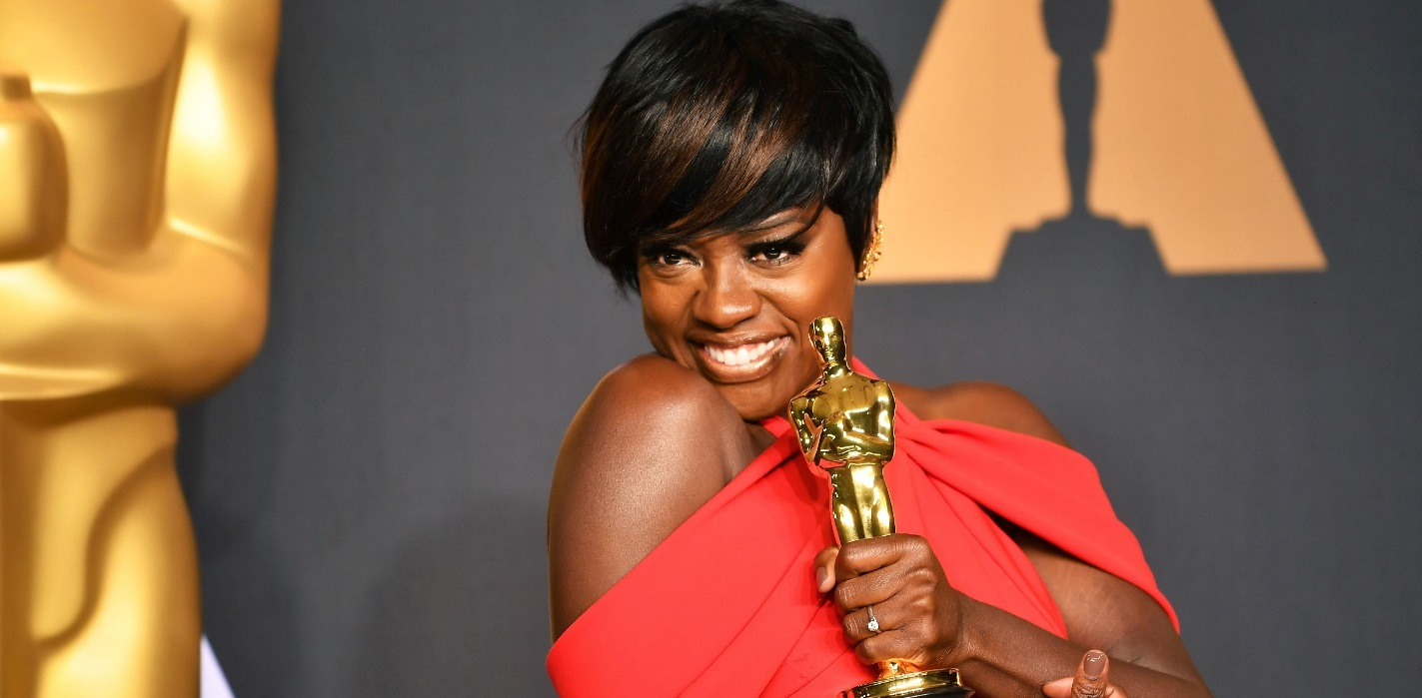

**“We are the only profession that celebrates what it means to live a life”** Viola Davis 2017 Best Supporting Actress, Acceptance Speech

**START YOUR ROAD TO THE OSCARS AT ASU!!!**

~TAKE A CLASS, AUDITION FOR A PLAY, OR MAJOR IN THEATRE at ASU~

**YOUR DRAMA, IS OUR DRAMA!**

FOR MORE INFORMATION CONTACT: Dr. Eve Graves at [eve.graves@asurams.edu](mailto:eve.graves@asurams.edu), Dr. Florence Lyons at [florence.lyons@asurams.edu](mailto:florence.lyons@asurams.edu) or Professor Deborah Liss-Green at [Deborah.lissgreen@darton.edu](mailto:Deborah.lissgreen@darton.edu)