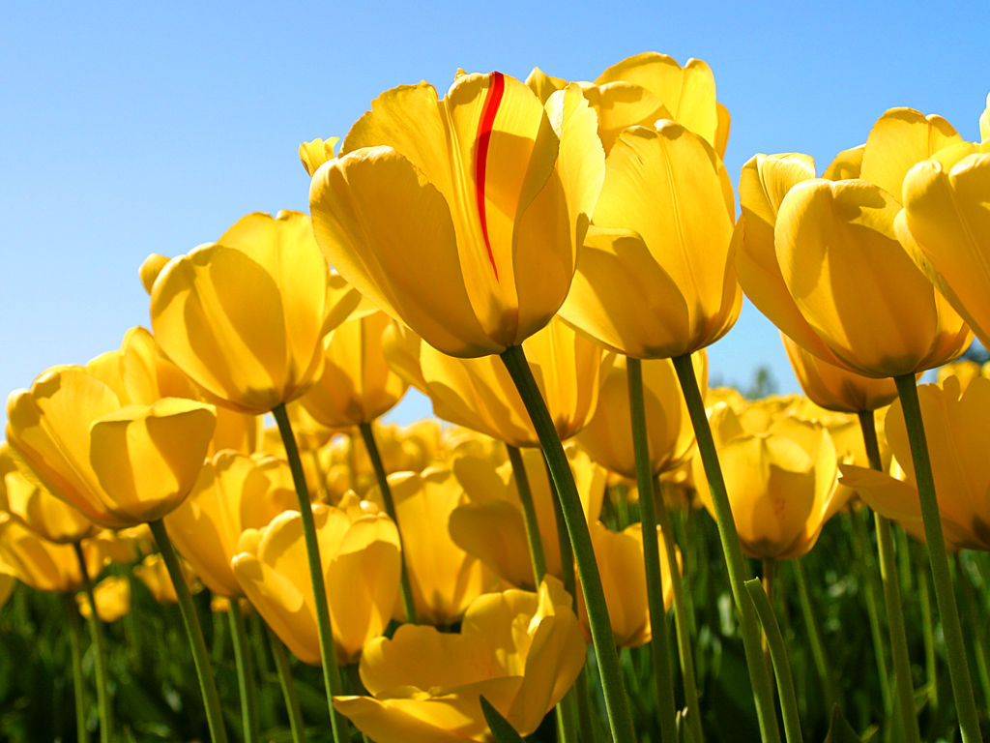
Band Personnel
Flutes-Genese Mandouma, Carol Kluball, Michael Decuir, Regina Holt

Oboe-Dr. Christopher Walker

Bassoon-Emily Young

Clarinets-Michael Hardy*, Ngina Mandouma, Fonda Marbury, Chanelle Norman, Tessa Sizemore, Mitchell Rosa

Bass Clarinet-###### Buckhalter

Alto Saxophones-Samuel Lee Holley, Joshua Times *

Tenor Saxophones- Connor West, Dwight ########

Baritone Saxophone-Steve Parker

Trumpets-Mac Alexander, Joe Maxey, Charles Wilson *, Ritchey Marbury, Dr. Craig Mitchell, Dr. Kenneth Trimmins, Michael Blaze

French horns-Watson Guillebeau, Scott Young, Rebecca Holt

Trombones-Crystal Garner, Howard Frontz, Bill Hornback

Euphoniums-Wes Stone, Mark Lussier

Tuba-Richard Wigington

Percussionists-Kelly Young*, Brandon Buckhalter*, Joel Johnson, Paula Carter

Piano-Meri Beth Hillard
*Denotes Darton Student
A special thanks to
Deb Liss-Green-Asst. Professor of Theater,
Hailey Martin-Stage Manager/Lighting,
Eva Lawson and Amani Mitchell-Theater Stage Hands
for their assistance and contributions to tonight’s performance.

Albany State University West Campus
School of Fine Arts
presents the
Music Department’s
Spring Concert
Featuring the
Concert Choir,
Orchestra,
and
Concert Band
Dr. Arthur Dunning Dr. Rani George
University President Interim Dean, Humanities and Social Science

Dr. Jeff Kluball Dr. Marcia Hood
Fine Arts West Coordinator and Band Director Fine Arts Chair

Dr. Claire Fox Hillard Paula Dee Carter
Orchestra Director College Choir Director
April 25, 2017
7:30 p.m.
Darton Theatre

Darton State Choir
Selections

Three Canons
Bardos, Jajos (1899-1986) Hetven Kanon #47
Bardos, Lajos (1899-1986) Hetven Kanon #29 Oz (Fall)
Cherubini, Luigi (1760-1842) Classical Canon #140

Niska Banja (Romani Dance) Arr. Nick Page
Trio: Flor Ceniceros, Theron Wakefield, Kelly Young
Yelp: Kelani Cherot, Keisha George

Choral Members:
Sopranos: Kelani Cherot, Leiah Moffett, Ainsley Reed, Y’Tamalicia
Shaw
Altos: Flor Ceniceros, Keisha George, Kelly Young
Tenors: Kere Wheeler, Brandon Wilson
Basses: Tristan Lawson, Theron Wakefield

Accompanist: Meri Beth Hillard

Darton State/Community Orchestra
Selections
3 Contradances, K. 609 W. A. Mozart
Allegro
Allegro
Allegro moderato

Trumpet Concerto in D major G. P. Telemann
Adagio
Allegro
Dr. Kenneth Trimmins, trumpet
Orchestra Members:
Violins: Donna Graf-blow, Davin Tennie-Jones*, Sophia Mendez *,
Tram Vi Nguyen Vo, Uyen Tho Pham Thi, Elaine Bush
Violoncellos: Maruice Figgins, Danny James
Bass: Trent Harper,
Albany State/Community Concert Band
Selections
Dedicatory Fanfare Bill Cherry

Hands Across the Sea March John P. Sousa

Songs of Grace and Songs of Glory John P. Sousa/Arr.Thomas Root

Fugue on Yankee Doodle John P. Sousa/Arr. Brion & Schissel

Voices from the Thronoteeska Ralph Ford

Rushmore, A Symphonic Prologue for Winds Alfred Reed

Seventy Six Trombones (from Music Man)
Meredith Willson/Arr. Anderson & Bocook

