Main Page

**MARC TO BRIDGE PROGRAM**

**Maximizing Access to Research Careers**

**Supported by a grant from the National Institutes of General Medical Sciences (NIGMS), a Division of the National Institutes of Health (NIH).**

Current MARC Programs:

**Now Accepting Applications for the 2016-2017 Academic Year!**

**(Apply Now! / Informational Meeting)**

**Faculty Development Series**(Flyer / Registration)  
Guidance and Advising (Request Form) — Document Review (Request Form)  
SWAT Team High School Summer Program (Brochure / Registration Closed)  
Fall Semester GRE Tutorial Sessions (Flyer / Registration Closed)  
For more information contact: MARC[at]asurams.edu

**Welcome to the “ASU MARC to BRIDGE” Program.**  The Maximizing Access to Research Careers to Bring Research Intelligence for Deeper Growth and Exhalation (MARC to BRIDGE) Program is designed to bridge the gap between undergraduate and graduate education, by preparing undergraduate students for entry into high-caliber graduate programs.  The MARC Program achieves this through a variety of initiatives including strengthening the science course curricula, the instructional skills of faculty, and research training for both students and faculty.

MARC is a two-year program, beginning in the student’s junior year, which provides the opportunity for students to work closely with a faculty research mentor on a topic related to the student’s interest.  In addition to research experience during the academic year, the MARC Program includes an intensive summer research experience at another University or NIH institute. MARC Scholars receive a stipend throughout the program, as well as support for travel to the summer research program and partial reimbursement of tuition costs among other benefits.

**To Apply for the MARC Program**

**Application for the 2016-2017 academic year is now available!**.

1. Review information presented in the student eligibility section.
2. Submit completed MARC Application, personal statement, two letters of recommendation, and a copy of your unofficial transcript to Dr. Jain (BCBb 306), Ms. Sloan (BCBb 328), or Dr. Roosta (Simmons 347).
3. All materials will be reviewed by the selection committee and interviews will be scheduled for final selection of MARC trainees.

Goals Page

# GOAL OF THE MARC PROGRAM

The goal of the “ASU MARC to BRIDGE” Program at Albany State University is to prepare high achieving students to successfully enter Ph.D. or M.D./Ph.D. graduate programs by providing academic support and a stimulating research experience. The hope is that our scholars will complete their Ph.D. or M.D./Ph.D. in a biomedical-related research field and begin a long and rewarding career in the biomedical sciences. Therefore, as a MARC scholar you will have the opportunity to become involved in research-related activities that will improve critical thinking skills resulting in deeper academic growth.

#### Specific Program Goals and Achievements:

* Increase the scientific rigor of STEM majors at ASU.  
  **Complete**: The MARC program achieved this goal with the addition of four new interdisciplinary science courses: Biology Senior Research, Laboratory Research Techniques, Responsible Conduct of Research, and Scientific Communication.
* Boost the instructional skills of Faculty at ASU.  
  **Ongoing**: In conjunction with Magna Publications the MARC program has instituted several Faculty Development Series open to all faculty and staff.  These series provide ideas as well as a forum to ask questions and receive support from seasoned faculty at ASU.
* Provide research training skills to Students and Faculty.  
  **Ongoing**: Throughout the year the MARC program holds hands-on training workshops that are open to all faculty and students.
* Increase the number of students entering PhD programs.  
  **Ongoing**: To assist ASU graduates planning to enter various graduate programs, the MARC program sponsors GRE Prep tutorial session, career and academic advising, document review, and information on internships and graduate programs across the country.

Benefits Page

# BENEFITS OF THE MARC PROGRAM

#### **Non-MARC students** at Albany State University can take advantage of all MARC sponsored events that take place throughout the academic year including:

* Free GRE Prep Course during fall semester;
* Hands-on research training workshops during spring semester;
* Advice and guidance on graduate programs or health career choices;
* Information on summer internships;
* Resume and personal statement critiques.

For more information check out our list of upcoming and current programs!

To become a MARC Scholar, an ASU student applies during the spring semester of his or her sophomore year. New scholars are selected during their junior year and receive individualized program support to enhance their chances of admission to competitive graduate degree programs.  NIGMS grant-funded students who successfully complete the rigorous academic program receive summer research internships, opportunities to present research at national and local research conferences, and assistance in completing graduate school applications.

#### Other Benefits for MARC Scholars Include:

* A monthly stipend;
* Tuition assistance (up to 60%);
* Summer internship support;
* Travel allowance to conferences;
* Placement in a research lab with a mentor;
* Professional development and academic advising.

Eligibility Page

# STUDENT ELIGIBILITY

#### **To be considered for participation in the MARC Program students must meet the following criteria:**

* Be a U.S. citizen or permanent resident;
* Full-time student enrolled at Albany State University and majoring in Biology, Chemistry, Mathematics or Computer Science;
* Junior with 60 or fewer credits remaining before graduation;
* Have a cumulative GPA of 3.0 on a 4.0 scale;
* And foster a strong interest in assisting with bio-medical research projects.
* Students ineligible for direct support through the MARC Program can participate in all MARC Sponsored events.

#### **As part of the application process students will be asked to submit:**

* A completed application;
* A personal statement;
* Written recommendations from two math or science faculty members;
* Unofficial transcripts;
* DegreeWorks Audit;
* [Two-year graduation plan](http://www.asurams.edu/wp-content/uploads/2015/12/Grad-Plan-Template.pdf).

### ****Expectations and Additional Requirements for MARC Trainees****

As a MARC scholar the expectation is that you will represent yourself, the University, and the MARC program in a positive light.  You are also expected to enter a graduate program after graduation from ASU.  To assist our students in this endeavor the program will provide many avenues of support, likewise we expect that our MARC scholars will:

* Participate regularly and fully in the Albany State University MARC research and training program including attending all workshops and research seminars during the academic year;
* Be punctual to and participate in all MARC program meetings;
* Register for and complete the five “MARC Courses”:  Laboratory Research Techniques, Responsible Conduct of Research, Scientific Communication, Bioinformatics, and Senior Research;
* Apply the knowledge gained in the classroom or laboratory to all interactions with other students, staff, faculty, administrators, and visiting scientists;
* Attend scientific meetings at the request of his or her professors—students attending scientific meetings are expected to represent the University in a scholarly and professional manner, to attend scientific sessions, and take advantage of the opportunities offered by various graduate schools;
* Register for and take the GRE during the spring semester of his or her junior year;
* Avoid outside employment during participation in the MARC program;
* Continue with post-graduate education and update the MARC program office of all achievements for a period of 10 years, or until a terminal degree is earned.

Programs and Events Page

# MARC SPONSORED PROGRAMS & EVENTS

### Guidance and Advising

Guidance and advising on graduate programs, summer internships, or health career options.  To request an advising session with any member of the MARC Staff simply fill out the advising request form and return it to the MARC Program Manager.  Someone will contact you to schedule an advising sessions when it is convenient for you!  
Advising Request Form

### Document Review

To have a member of the MARC Staff review your resume, CV, personal statement, or cover letter simply fill out the request form and submit your materials to the MARC Program Manager.  Once your documents have been reviewed someone will contact you to schedule a time to review the material, suggestions, and changes that should be made.  
Document Review Request Form

### GRE Prep Course and Tutorial Sessions

GRE Tutorial Sessions take place during the Fall Semester.  Sessions are offered FREE to all students and staff at Albany State University.  To participate simply fill out the registration form.Registration Closed, Informational Flyer

### Faculty and Staff Development Sessions

The MARC to BRIDGE Program has partnered with Magna Publications to bring you TWO exciting faculty and staff development series “Encouraging your students to come to class prepared” and “Supporting Learning Outcomes”.  These series will cover the following topics:

1. Encouraging your students to come to class prepared:
   * How Do I Get Students to Come to Class Prepared?
   * How Do I Effectively Use Class Preparation Assignments?
   * How Do Prepared Students Change the Way I Teach?
2. Supporting Learning Outcomes:
   * How Can I Use Discussion to Facilitate Learning?
   * How Can I Get Students to Take Responsibility for Their Own Learning?
   * How Can I Enhance the Impact of Feedback in Online Classes?
   * How Can I Make My Exams More about Learning, Less about Grades?

Magna Publications provides a short (<20 min) video and we follow-up with light refreshments and enlightening discussion. Interested faculty are asked to register using the link below to let us know when you are available to participate.Faculty Development Registration, Flyer

Internships & Grad Programs Page

**SUMMER INTERNSHIPS & GRADUATE PROGRAMS**

The MARC Program Office is regularly contacted by recruiters from institutions all over the US.  We maintain a constantly updated list of these programs.  Click the links below to get more information.

**Featured Programs of the Month**

**Internship Programs**

**Post-Baccalaureate Programs**

**Graduate Programs**

To report corrections, errors (broken links, etc), or have your program added contact the MARC Program Office: MARC@asurams.edu or fill out our program form: Extramural Program Form

MARC Scholars

**MARC TO BRIDGE SCHOLARS**

**Meet the Current and Past ASU MARC to BRIDGE Scholars**

|  |  |  |
| --- | --- | --- |
| **2015 MARC Scholars** | | |
| Courtney Wallace Biology | Amanda Holloman Computer Science | Alexius Lampkin Forensic Science & Chemistry |
|  | Victoria Stephens Forensic Science Chemistry Minor |  |
| **2014 MARC Scholars** | | |
| [http://www.asurams.edu/wp-content/uploads/2015/08/Hodge-300x225.png](http://www.asurams.edu/wp-content/uploads/2015/08/Hodge.png)Le’Aaricka Hodge Biology | [http://www.asurams.edu/wp-content/uploads/2015/08/Hunt-300x225.png](http://www.asurams.edu/wp-content/uploads/2015/08/Hunt.png)Jaden Hunt Biology | [http://www.asurams.edu/wp-content/uploads/2015/08/Jones-300x225.png](http://www.asurams.edu/wp-content/uploads/2015/08/Jones.png)Jeremy Jones Mathematics |
| **2013 MARC Scholars** | | |
| [http://www.asurams.edu/wp-content/uploads/2015/08/Toatley-300x225.png](http://www.asurams.edu/wp-content/uploads/2015/08/Toatley.png)Briana Toatley Biology |  | [http://www.asurams.edu/wp-content/uploads/2015/08/Brown-300x225.png](http://www.asurams.edu/wp-content/uploads/2015/08/Brown.png)Kristopher Brown Chemistry |
| **2012 MARC Scholars** | | |
| Ashley McMichael Biology | Teretha Taylor Computer Science | Ayunna Epps Chemistry |

MARC Staff

**MARC TO BRIDGE PROGRAM STAFF**

[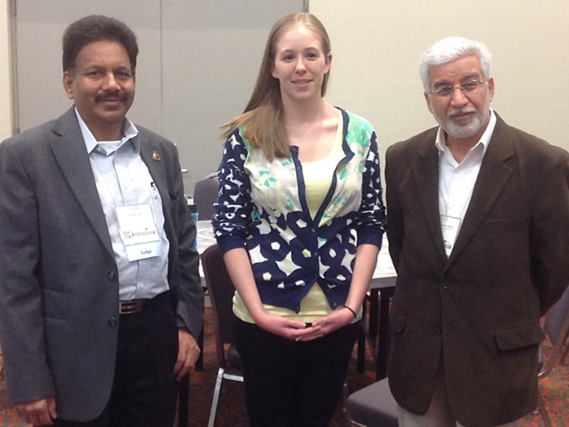](http://www.asurams.edu/wp-content/uploads/2015/08/MARC-Staff.png)

MARC Program Staff (left to right: Dr. Jain, Ms. Sloan, Dr. Roosta) at ABRCMS 2014 in San Antonio, TX

**Amy Sloan, MS;**MARC Program Manager and GRE Instructor  
amy.sloan @ asurams.edu or BCB 328; 430-2827

**Ashok K Jain, PhD**; MARC Program Director and Professor of Biology  
ashok.jain @ asurams.edu or BCB 306; 430-4817

**Seyed Roosta, PhD**; MARC Program Co-PI and Chair of the Dept. of Mathematics and Computer Science  
seyed.roosta @ asurams.edu or Simmons 346; 430-4885

High school summer program Page

# HIGH SCHOOL SUMMER PROGRAM

### Summer Science Will Amaze Them (SWAT) Team

The Science Will Amaze Them (SWAT) Team is a summer program for local area high school students interested in attending college and majoring in a STEM field.  SWAT Team participants gain the experience of college education while also getting to complete complex research problems.

The SWAT Team is a 6-week program, beginning on June 1st.  Participants attend classes, eat meals, and perform research Monday – Thursday from 8 am – 4 pm.  For more information contact the MARC staff or check out our SWAT Team brochure.

Registration for Summer 2015 SWAT Team is closed.  Check back in March of 2016 for next years application!

Forms Page

# FORMS

### Applications

2016_MARC Application (ASU Students)

2016 Summer SWAT Team Application (High School Students)

### Program Participation Forms

GRE Prep Course Registration Closed

Faculty Development Registration

Advising Request Form, Email completed forms to: MARC @ asurams.edu

Document Review Request Form, Email completed forms to: MARC @ asurams.edu

### Forms for MARC Scholars

Monthly Report

Monthly Student Assessment

MARC Calendar of Assignments (Meeting Calendar)

Travel Approval Form

Graduate Program Form (Example)